Freedom-to-Operate Searching: Importance, Scope, and Practical Methodology
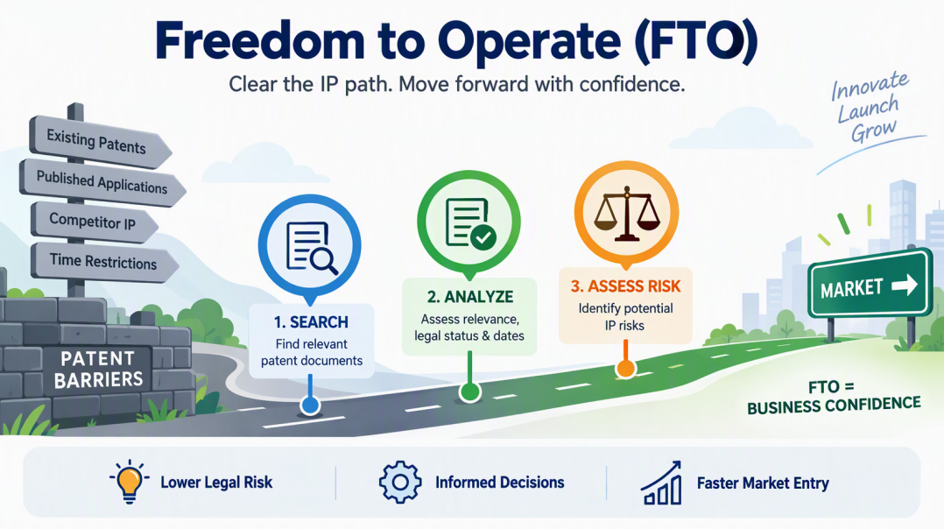

- What Is FTO?
Freedom to Operate, or FTO, is an intellectual property assessment that companies and start-ups undertake to determine whether they can launch a product in a particular region. It identifies whether any person or entity owns a patent in that region that may cover the product.

An FTO search is performed to determine whether a product can be placed on the market without creating a significant patent infringement risk. It involves identifying potentially relevant patent holders and assessing whether the planned product may fall within the scope of their enforceable patent claims in the relevant jurisdiction.
An FTO search reduces uncertainty but does not guarantee that every relevant patent has been identified or that the product cannot be challenged.

2. Why FTO Is Important
An FTO search provides a company with greater confidence that it can launch its product without infringing another party’s patent rights. Therefore, companies conduct extensive research before launching their products.
FTO searching is generally conducted during the early stages of product development and before a substantial investment is made. Its purpose is to reduce the possibility of patent disputes or infringement lawsuits after the product is launched.
An FTO search allows potential patent risks to be identified before the company proceeds further. Companies conduct FTO searches more frequently in jurisdictions where patent enforcement risks are significant. The analysis must be performed precisely by considering the relevant patent databases and jurisdictions.
If a product includes a key feature that is already covered by another party’s patent, the company may face legal and commercial risks. Depending on the circumstances and the legal advice received, the company may consider the following options:
- Redesigning the relevant feature to reduce the infringement risk
- Negotiating a licence with the patent holder and agreeing to pay royalties
- Conducting a patent invalidity search to identify prior art that could challenge the validity of the patent
- Exploring other legal remedies with qualified legal counsel
An FTO assessment can increase investor confidence and support informed decisions regarding product development, investment, licensing, and risk mitigation.
The service provider must conduct the search carefully because a missed patent may expose the client to significant risk. A missed patent or an incorrectly classified result may create a false positive or false negative and lead to serious legal and commercial consequences.
3. How FTO Is Conducted
3.1 Defining the Search Requirements
Before conducting the search, the client must provide clear guidelines regarding the patents and patent applications to be considered. These may include granted and active patents, published patent applications, active European patent applications approaching grant, active PCT applications within the applicable national or regional phase-entry period, recently expired patents, recently lapsed patents, and recently abandoned patent applications.
The applicable legal-status and date guidelines should be confirmed with the client before proceeding with the FTO search.
The client must specify the jurisdictions in which the product will be launched and the FTO search must be conducted. The client should also be asked which patent databases, search tools, and jurisdictions must be considered.
The search team should clarify whether the client requires the use of any specific database or patent search tool before beginning the FTO search.
3.2 Client-Specific Date Guidelines
The search team must adhere to the date guidelines specified by the client. These guidelines may include:
- Granted and active patents
- Published patent applications
- Granted and active European patents within the client-specified three-month period
- Published and active WO or PCT applications within the applicable national or regional phase-entry period
- Patents that expired within the previous two years
- Patents that lapsed within the previous two years
- Patent applications that were abandoned within the previous two years
These time periods are examples of client-specific search and reporting instructions. They are not universal FTO rules and may vary according to the jurisdiction, product, and agreed project scope.

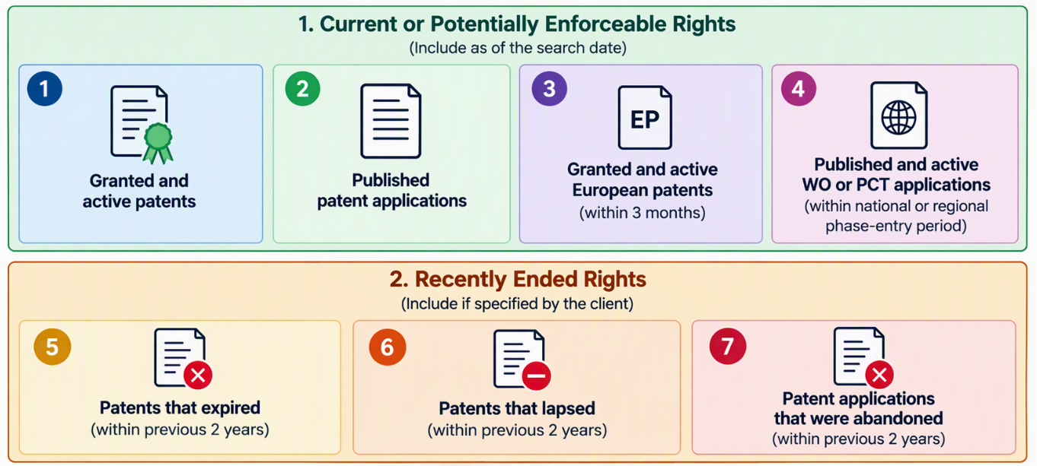

3.2.1 Active Granted Patents
Active patents that have been granted in the relevant jurisdiction and remain legally enforceable are important records in an FTO report. These patents have not expired, lapsed, been revoked, or been invalidated.
They should be given the highest priority and placed near the beginning of the report so that the client can review them easily.
3.2.2 Published Patent Applications
Published patent applications that have not yet been granted may receive the next level of priority. These applications may still be pending and could later be granted. However, they may also be:
- Abandoned
- Withdrawn
- Rejected
Pending published patent applications should be shown separately from active granted patents.
3.2.3 Recently Granted European Patents
The three-month period may relate to post-grant validation requirements in certain European countries. A granted European patent may require validation in the selected European countries according to the applicable national requirements.
The three-month period does not mean that a granted European patent can enter the United States or another national phase. The relevant European countries and applicable validation requirements should be considered.
3.2.4 Published WO or PCT Applications
A WO publication is a published international application filed under the Patent Cooperation Treaty. After filing a PCT application, the applicant may enter the national or regional phase in selected jurisdictions.
The applicable period is commonly 30 or 31 months from the filing date or, when priority is claimed, from the earliest priority date. The exact deadline depends on the relevant national or regional office.
The 31-month period applies to entry into the European phase before the European Patent Office.
3.2.5 Recently Expired Patents
Expired patents may be included in the FTO report when required by the client. If expired patents are identified during the search, they may be listed separately to demonstrate the coverage of the search and give the client confidence in the analysis.
Expired patents should be placed in a lower or separate section of the report so that the client does not confuse them with active patents.
An expired patent generally no longer presents the same infringement risk as an active patent. However, it may contain relevant technical disclosures and may be useful as prior art when assessing the validity of claims in another patent.
Expired patents should not be described as a means of extending the scope of the client’s patent.
Patents that expired within the previous two years may be retained in the report when required by the client.
For example, if the FTO cutoff date is September 29, 2026, the client’s two-year guideline may include patents that expired on or after September 29, 2024.
3.2.6 Recently Lapsed Patents
Patents that lapsed within the previous two years may be retained in the report when required by the client.
These patents should be listed separately from active granted patents to prevent confusion. Their inclusion and placement in the report should depend on the client’s specific requirements.
3.2.7 Recently Abandoned Patent Applications
Patent applications that were abandoned within the previous two years may also be retained when required by the client.
These abandoned applications should be listed separately from active patents and pending published applications. Their inclusion and placement in the report should depend on the client’s specific requirements.
3.2.8 Client-Specific Requirements
The inclusion of recently expired patents, lapsed patents, and abandoned patent applications depends on the client’s requirements.
The two-year periods are client-specific restrictions or reporting guidelines. They are not universal legal requirements.
3.3 Understanding the Product
If a company plans to launch a medical device, all its key features should be recorded clearly. The product document should explain the mechanisms used to implement each feature, the main components of the device, and the relationship between the components and the features.
The product should be divided into relevant technical features. These features may be searched individually and in appropriate combinations.
3.4 Identifying the Key Features
There are several steps involved in conducting an FTO search. When a company presents its product, the first step is to identify and list all the key features of that product.
For example, if a product has five important key features, a list of those features should be prepared for use in the FTO search.
Invention: An aerosol-generating device comprising a removable cap or cover configured to fit onto one end of the device during use, wherein the cap or cover is secured to the device through an interference fit.

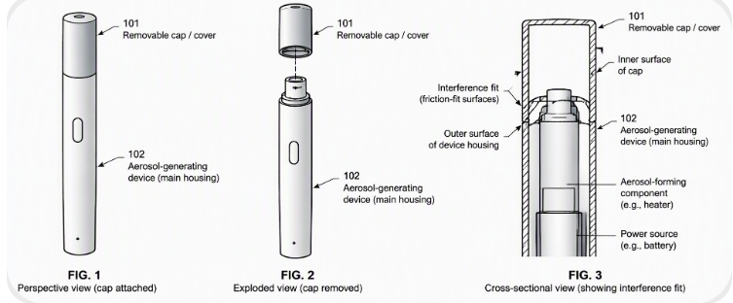

Key-Features:
- Aerosol-generating device with a removable cap or cover.
- The cap or cover fits onto one end of the device during use.
- The cap or cover is secured to the device through an interference fit.

3.5 Preparing and Conducting the Search
Suitable search strings must be prepared for the selected patent databases. Based on the client’s requirements, the search team must identify relevant keywords, patent classifications, and search databases. Different keyword variants should be prepared for every key feature.
Multiple search strings should be executed across the selected databases, and the resulting patent records should be extracted for analysis. Each key feature must be framed precisely. All the key features of the product must be identified separately.
A patent may be relevant to one key feature but not to another. Therefore, the analyst should clearly indicate the feature for which the patent has been marked as relevant. For example, key-features of the invention can be framed of the invention in below manner:
The search may use:
- Different keyword combinations
- Diversified keywords and synonyms
- CPC and IPC classifications
- Assignee searching
- Inventor searching
- Citation searching
- Patent-family searching
- Image or drawing-based searching, where appropriate
- Other relevant search techniques

4. Relevance Classification and Feature Mapping
4.1 Relevant, Related and Non-Relevant Records
If a patent claim appears to correspond to a key feature of the product, the patent may be marked as potentially relevant for further analysis.
If a key feature of the product is disclosed in the specification but not in the claims, the patent may be marked as related.
If a patent claim or specification do not appears to correspond to a key feature of the product, the patent may be marked as potentially non-relevant.
The labels “relevant,” “related,” and “non-relevant” should be defined in the report because their meaning may depend on the agreed project methodology.

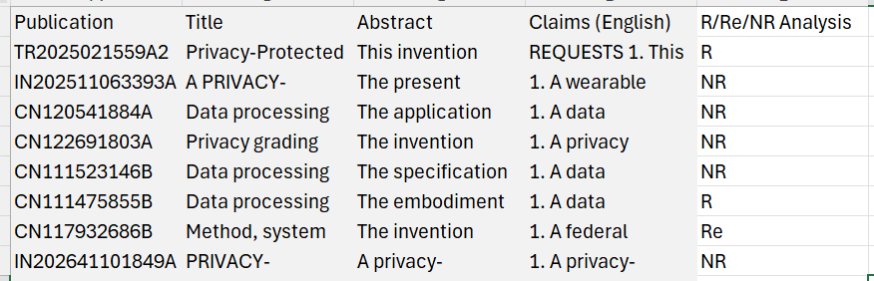

4.2 When Patent Claims and Specifications Are Considered During an FTO Search
The categorisation depends on the client’s requirements and whether the client wants the analysis to cover only the claims or both the claims and the specification.
The project budget may also be determined according to this requirement. If the client wants only the claims to be considered, the project may be less expensive. If the client also wants the patent specification to be considered during the analysis, the project budget may increase because additional analysis is required.
A client may request a review of the specification because a continuation or related patent application may be filed later. When permitted by the applicable law and supported by the original disclosure, an applicant may pursue claims in a continuation or related application.
Therefore, to remain on the safer side, the client may extend the project budget and timeline and ask the FTO service provider to consider the specification and related pending patent-family members.
This analysis may help the client identify potential hurdles during the launch or future implementation of the product in the market. For this reason, patent specifications are sometimes considered during an FTO search, while at other times, the analysis is limited to the claims.
4.3 Conducting Relevant, Related and Non-Relevant Analysis
After executing the searches, the results must undergo relevant and non-relevant analysis. Patents that do not disclose a relevant feature may be marked as NR, while relevant patents may be marked as R.
If a product has five key features, the initial relevant and non-relevant analysis may identify a patent as potentially relevant when it covers at least one of those features.
The analyst should clearly indicate the feature for which the patent has been marked as relevant. This feature-level analysis helps determine which patents are relevant to each part of the product.
After extracting the patent result set, the team should conduct the relevance analysis based on the claims, legal status, jurisdiction, and applicable date requirements. Each patent may be marked “Yes” or “No” against every key feature.
The search team should review every key feature, document the applied filters, analyse the relevant technologies, examine patent families, and record the legal status of the shortlisted patents.
4.4 Preparing a Relevance Matrix
To avoid confusion among team members, a relevance matrix should be prepared.
The matrix may indicate whether each patent is relevant or non-relevant to each key feature. For example, if a product has three key features, the relevance matrix may show the relationship between each patent and those three features.
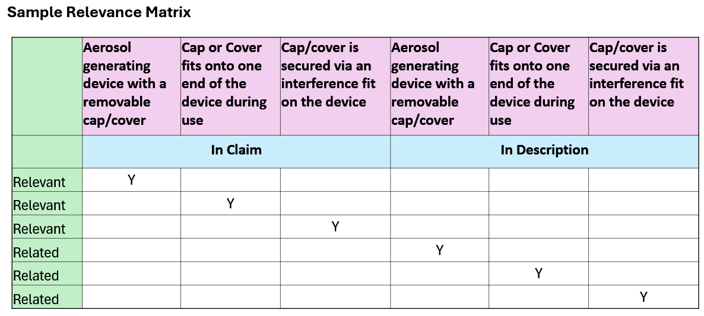

5. Conducting Quality-Control Reviews
FTO search results should undergo multiple quality-control reviews to minimise the risk of missing potentially relevant patents.
The search team should conduct a comprehensive and carefully reviewed search. Multiple quality-control stages should be completed by experienced reviewers.
The quality-control review may cover the identified key features, applied search strategies, relevance classifications, patent families, jurisdictions, legal statuses, and final report.
6. Preparing the Final Report
A structured report should be prepared for the client. The report should identify the patents relevant to the first feature, the patents relevant to the second feature, and the corresponding patent sets for the remaining features.
The resulting report should be informative and should help the client determine whether to proceed with the product, redesign it, negotiate a licence, or take another suitable action.
The final analysis should clearly identify the patents relevant to each key feature and explain the applicable search scope, jurisdiction, legal status, and limitations.
While preparing the report, the analyst must determine which patent sets should be marked as relevant, related, or non-relevant according to the agreed methodology.
The search team may prepare a technical FTO search report identifying potentially relevant patent records. A formal legal opinion concerning infringement or freedom to operate should be provided by a qualified legal professional authorised to advise in the relevant jurisdiction.
Disclaimer
This article is provided for general educational purposes only. It does not constitute legal advice or a legal opinion. Freedom-to-operate assessments depend on the applicable jurisdiction, product configuration, commercial activities, claim interpretation, legal status, and specific facts. Qualified legal counsel should be consulted before making commercial or legal decisions.

